Part 1 – James Grey, Hector Perez, Jordie Shier, Adar Guy

Apply the compressor effect to the Tom's Diner track. Use the compressor effect in

Audacity or another compressor.

1.1. Experiment with two different settings of threshold and ratio using the default

values of attack time 0.2 sec and release time 1.0 sec and describe the results.

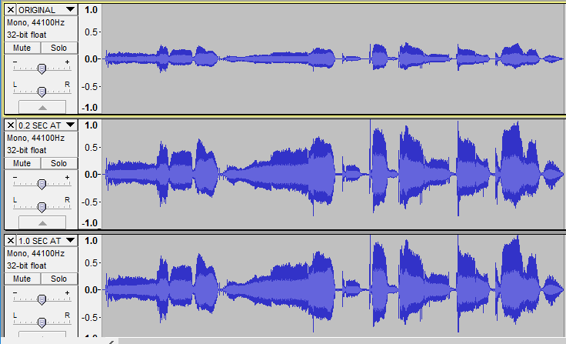Attempt 1: Threshold: -42dB Ratio: 3:1 Attack time: 0.2 Sec

Description: The overall level seems higher. Visually, the low level sections from the original are now closer to the high level sections from the original.

Attempt 2: Threshold: -42dB Ratio: 3:1 Attack time: 0.2 Sec

Description: The overall level seems higher.

1.2. Experiment with two different settings of attack time and release time using the

threshold of 36 dB and ratio of 10:1 and describe the results.

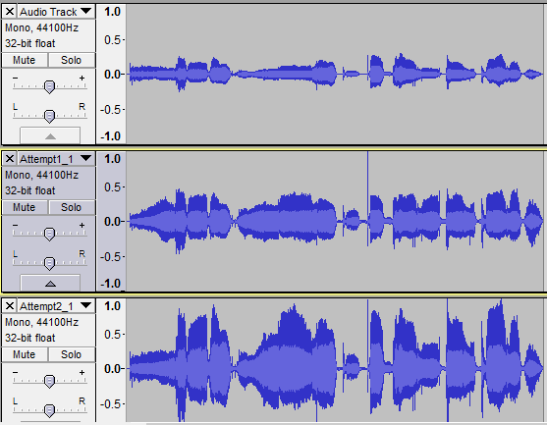

Attempt 1: Threshold: 36 dB Ratio: 10:1 Attack: 0.1 Sec Release: 1.0Sec

Description: The audio displays ‘holes’ where the change between the compression and non-compression bring the level up or down. The sound does not appear steady.

Attempt 2: Threshold: 36 dB Ratio: 10:1 Attack: 1.0 Sec Release: 3.0Sec

Description: The

same effect is audible, thought it is a little less evident.

Assessment (8/46 marks)

* 1. Description of 2 results and comparison to original 4 marks

1.2 Description of 2 results and comparison to original 4 marks